HAIYAN DAZHONG NUT CO.LTD, was established in 1980, is a professional manufacturer of standard fasteners, the mainly products are hex nuts, threaded rods, anchor bolts and casting expansion pipe. Our company has passed the international quality management system ISO9001:2000, it could produce according with DIN934 (Code forging: M6-M24; Hot forging: M27-M62), DIN975 (M5-M52), ANSI (1/4"-2.1/2"), BS, ISO and GB, also could product the non-standard fasteners, which deal with your drawer or sample.
Our company is located in the big bridge new district, Economic Development Zone in Haiyan. The traffic is very convenient. Our company occupies 23,000 square meters, owes over 180 sets fasteners machinery (150 sets hex nuts machine and 30 sets threaded rods machine) and the annual output value exceeds 30 million RMB.
Because of the high quality and competitive price, ours products are sale well in AMERICA, EUROPE, MIDDLE-EAST and any other place.
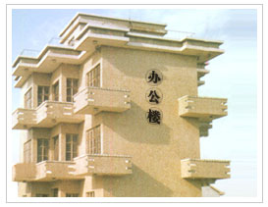
Our company tenet: living on high quality, developing with high credit. And basis on the credit standing, we are willing to make cooperation together with world colleagues to create a bright future. 